Name : Saurabh Sanjay Jadhav.

Topic : DevOps - Git and GitHub

Assignment no. : 1

1. Create EC2 instance select Ubuntu OS and connect to instance.

**Public repository:**

1. Check git is installed or not using below command. Create new directory

Git – version

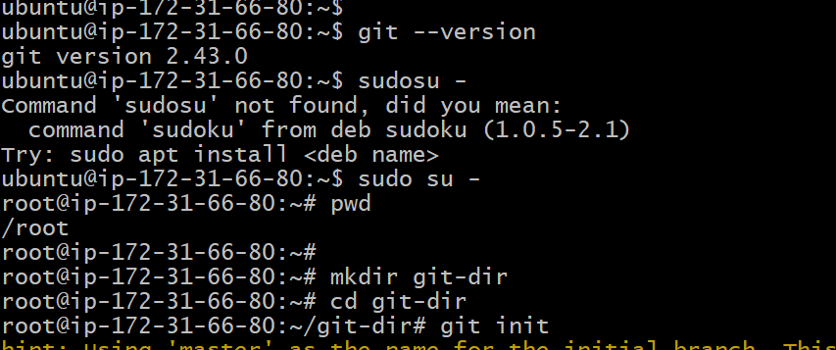

1. Initialize git in it. Create new files and directory in it.

1. Add files from working directory to stagging directory.

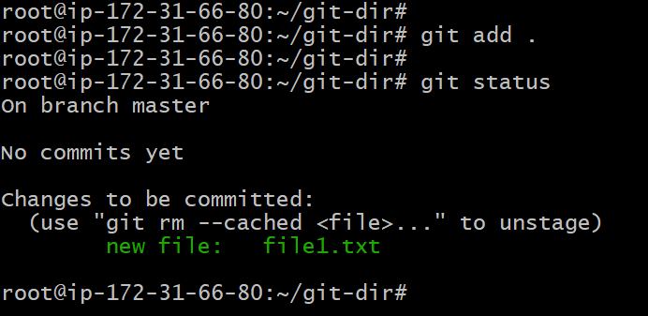

1. Create new file file2.txt and check status it is in working directory. Then add it in stagging directory.

1. Commit the files to git. Check the status. In this step the files will be moved to local repository.

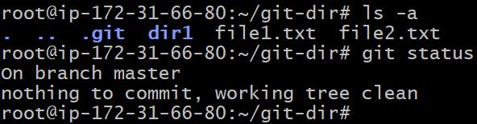

1. Create new remote repository in GitHub account. Provide public access.

1. We will see the dashboard below after creating the repository.

1. Add remote repository to git

1. Create access token for your account.

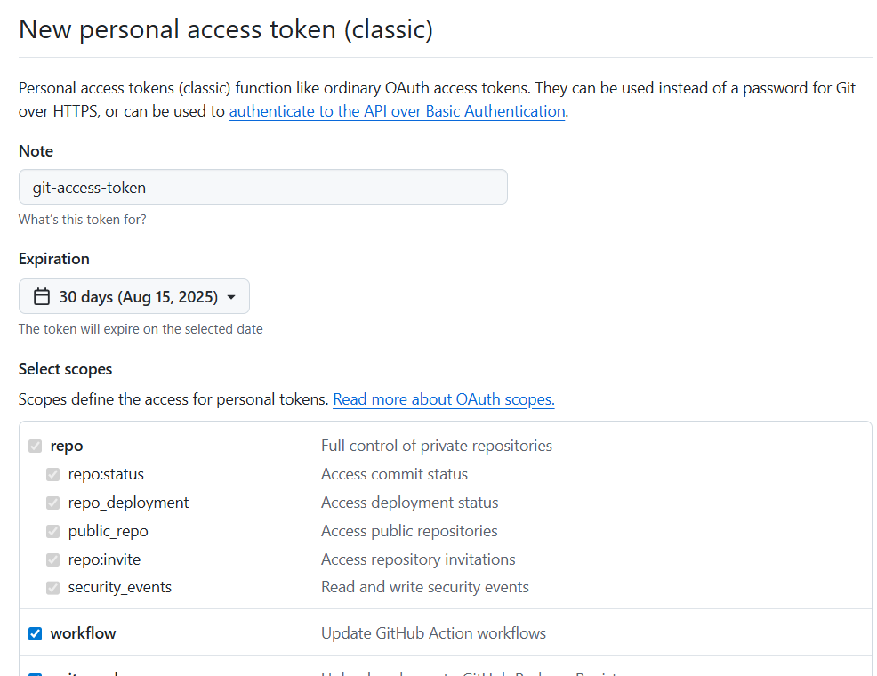

1. Successfully able to access remote repository.

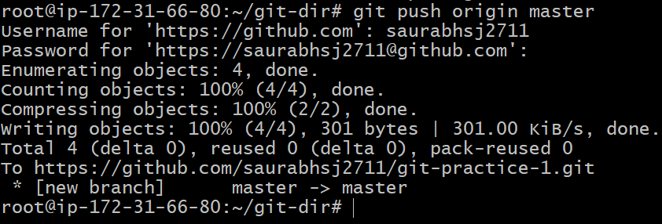

1. Successfully pushed files to remote repo.

1. Check all commits in git.

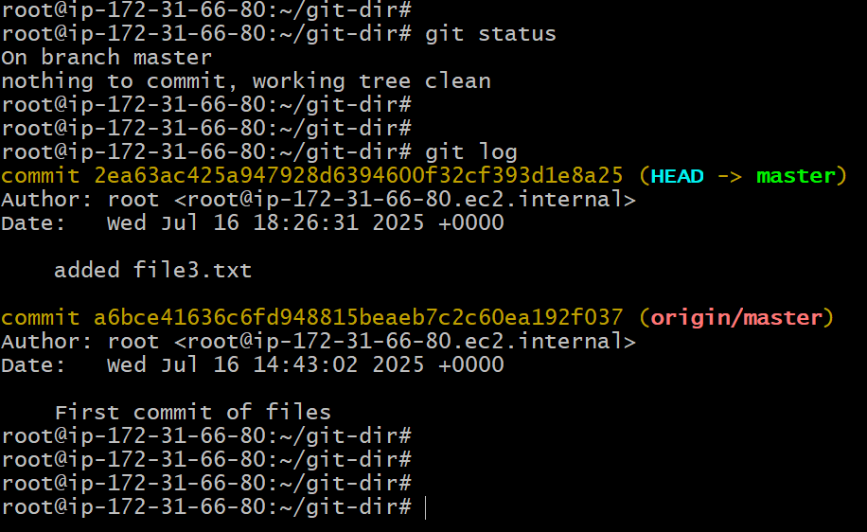

**Private repository:**

1. Create private repository. Select private access.

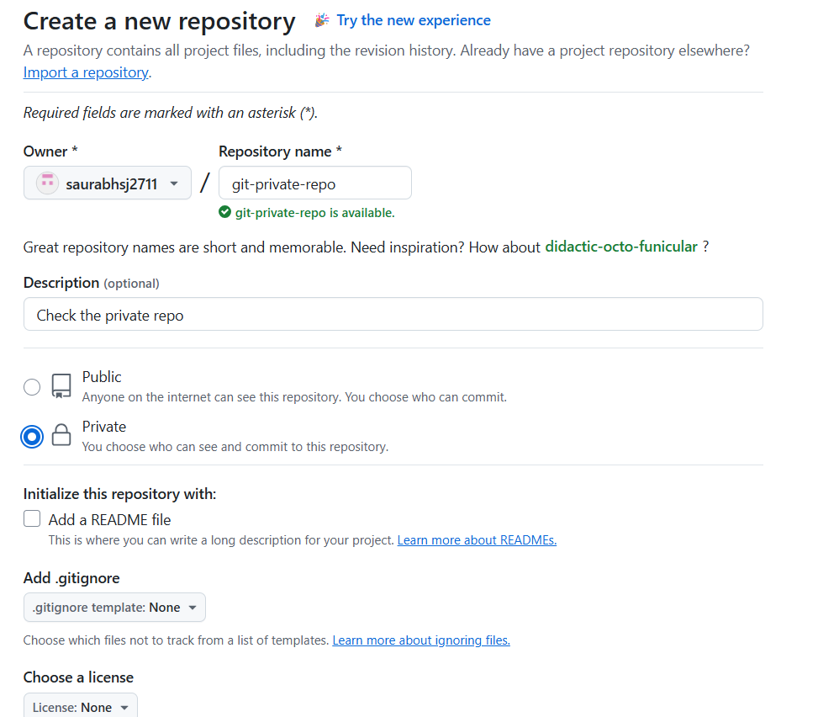

1. Create a folder git-private. Initialize git repo in it. Create new files and add files to local repo.

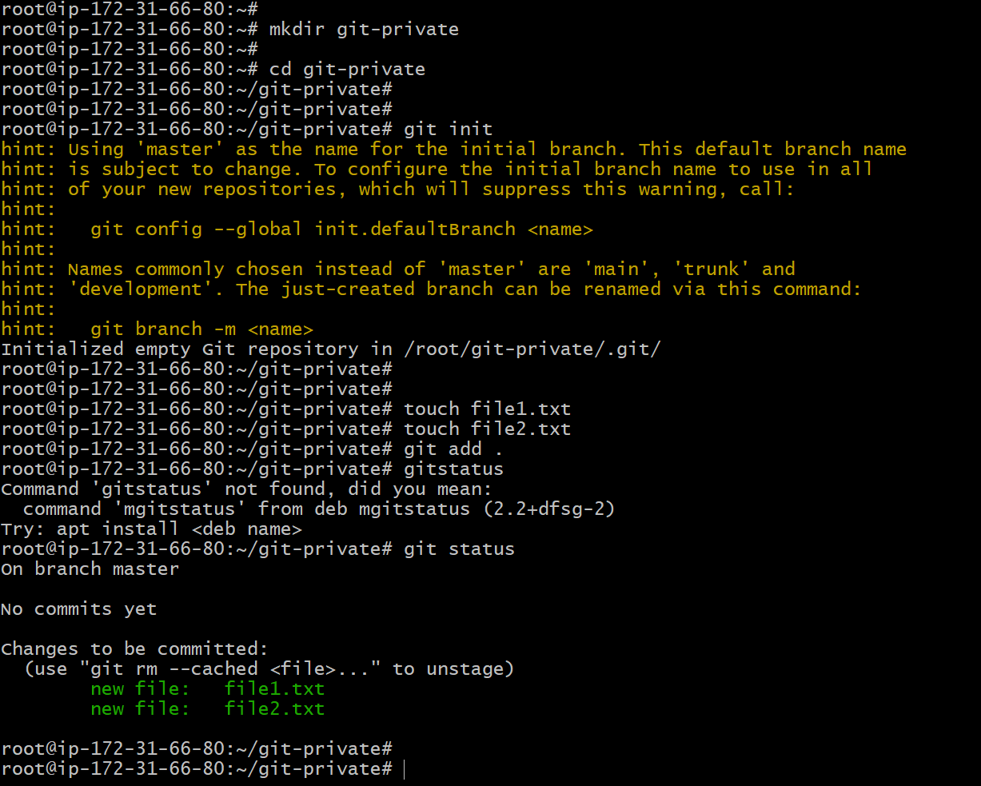

1. Push the files to remote repo.

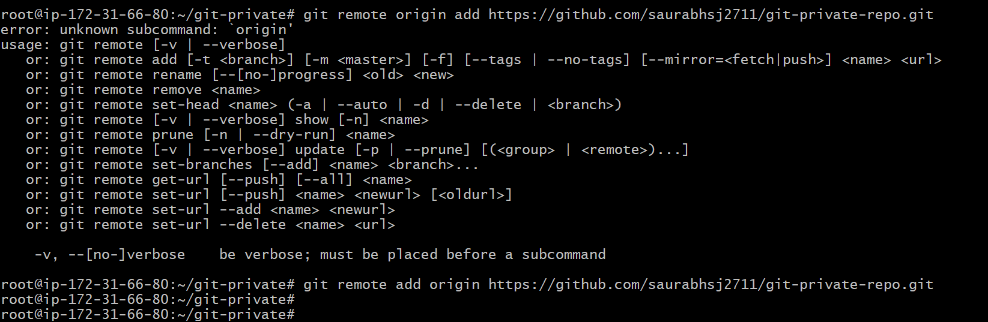

1. Successfully files are uploaded to remote repo.

